26.9.17 Editors - Properties Editor - Particle Properties Tab - Velocity panel
Velocity Panel 1
Normal 1
Tangent 1
Tangent Phase 1
Object Aligned X Y Z 1
Object Velocity 1
Randomize 1

Velocity Panel

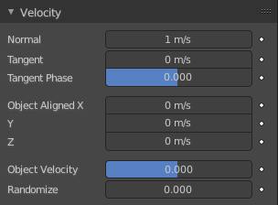
The initial velocity of particles can be set through different parameters, based on the type of the particle system.

Normal
The emitter’s surface normals (i.e. let the surface normal give the particle a starting speed).

Tangent
Let the tangent speed give the particle a starting speed.

Tangent Phase
Rotates the surface tangent.

Object Aligned X Y Z
Give an initial velocity in the X, Y, and Z axes.

Object Velocity
Let the object give the particle a starting speed.

Randomize
Gives the starting speed a random variation.

